CV Assoz. Prof. Jörg Schachner, PhD

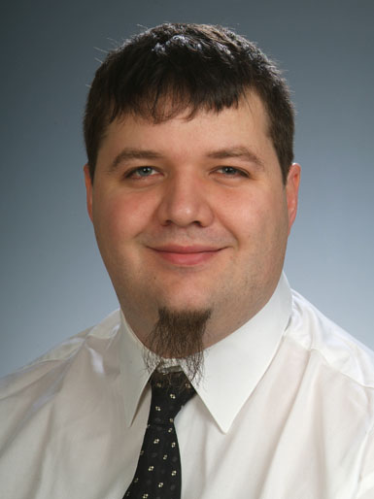

Education: PhD in Chemistry
Nationality: Austria
Date of Birth: 20/08/1977
Scopus/WoS
h-index: 19/19
no. of citations: 867/900 Publications: 47
ORCID: 0000-0002-1863-4680

Work address
University of Graz
Schubertstr. 1/III
A-8010 Graz
Email
joerg.schachner@uni-graz.at
Phone
Work: +43(0)316/8305287

Education and professional activities

Associate Professor (tenured) at the Institute of Chemistry, Inorganic Chemistry, Univ. of Graz.
Apr.2019 – currently

Assistant Professor (tenure track) at the Institute of Chemistry, Inorganic Chemistry, Univ. of Graz, supervised by Prof. Nadia C. Mösch-Zanetti.
Apr. 2013 – Mar. 2019

University Assistant at the Institute of Chemistry, Inorganic Chemistry, Univ. of Graz.
Aug. 2010 – Mär. 2013

Post-doctoral fellow at the joint Catalysis Research Laboratory in Heidelberg and at BASF SE, supervised by Dr. Michael Limbach. Project: Homogeneous olefin metathesis.
Nov 2008 – Juli 2010

Post-doctoral fellow at the Univ. of British Columbia in Vancouver, Canada, supervised by Prof. M. Fryzuk. Project: Homogeneous dehydrogenation catalysts employing novel pincer ligands.
Sep 2007 - Aug 2008

Graduate school at the Univ. of Saskatchewan, Saskatoon, Canada, supervised by Prof. Jens Müller; graduated with PhD degree 10.08.2007. Project: Ferrocenophanes containing the heavier group 13 elements Al, Ga and In.

Feb 2004 - Aug 2007
Highlights of scientific contributions in publications
1. Schachner, J. A.; Wiedemaier, F.; Zwettler, N.; Peschel, L. M.; Boese, A. D.; Belaj, F.; Mösch-Zanetti, N. C. Catalytic reduction of nitrate by an oxidorhenium(V) complex. J. Catal. 2021, 397. 108. 10.1016/j.jcat.2021.03.028
2. Schachner, J. A.; Belaj, F.; Mösch-Zanetti, N. C. Isomers in chlorido and alkoxido-substituted oxidorhenium(V) complexes: effects on catalytic epoxidation activity. Dalton Trans. 2020, 49, 11142. 10.1039/D0DT02352C
3. Schachner, J. A.; Berner, B.; Belaj, F.; Mösch-Zanetti, N. C. Stereoisomers and functional groups in oxidorhenium(V) complexes: effects on catalytic activity. Dalton Trans. 2019, 48, 8106. 10.1039/c9dt01352k
4. Zwettler, N.; Schachner, J. A.; Belaj, F.; Mösch-Zanetti, N. C. Oxidorhenium(V) Complexes with Tetradentate Iminophenolate Ligands. Inorg. Chem. 2016, 55, 5973. 10.1021/acs.inorgchem.6b00466
5. Schachner, J. A.; Terfassa, B.; Peschel, L. M.; Zwettler, N.; Belaj, F.; Cias, P.; Gescheidt, G.; Mösch-Zanetti, N. C. Oxorhenium(V) Complexes with Phenolate–Oxazoline Ligands: Influence of the Isomeric Form on the O-Atom-Transfer Reactivity. Inorg. Chem. 2014, 53, 12918. 10.1021/ic501932c
6. Traar, P.; Schachner, J. A.; Steiner, L.; Sachse, A.; Volpe, M.; Mösch-Zanetti, N. C. Oxorhenium(V) Complexes with Pyrazole Based Aryloxide Ligands and Application in Olefin Epoxidation. Inorg. Chem. 2011, 50, 1983. 10.1021/ic102455v
Highlights of other scientific contributions and awards
- Academic partner in the HORIZON-MSCA-2021-SE-01 call “Metal complexes of a naturally inspired framework functionalized for cytotoxic and catalytic efficiency”, MET-EFFECT, Project No.: 101086373. Jan. 2023 – Dec. 2026
- Schachner, J. A. Catalysis with the bidentate oxazoline ligand HEdmoz (E = O,S): high activities and new reactivities in Re and Mo catalyzed oxygen atom transfer reactions; Eur. Inorg. Chem. Conf. EICC-5; Moscow, Russia; 2019.
- Schachner, J. A. Challenging reactions catalyzed by simple complexes; Oral presentation; 7th EuChemS Conf. on N-Ligands; Lisbon, Portugal; 2018.
- Schachner, J. A., Rhenium catalyzed Reduction of Perchlorate and Nitrate; Oral presentation; Int. Conf. on Coord. Chem. ICCC; Sendai, Japan; 2018.
- Henry Taube Medal (best PhD thesis), Univ. of Saskatchewan Apr 2008
- Gerhard Herzberg Fellowship (5000 CAD), Univ. of Saskatchewan Apr 2007

