Musa Khaitov

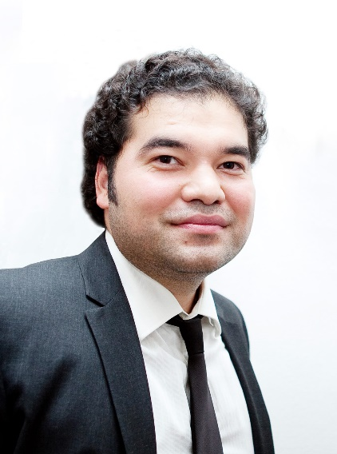 | Was born in August 31, 1979, Moscow. Director of the National Research Center Institute of Immunology of the Federal Medical and Biological Agency of Russia, Academician of the Russian Academy of Sciences, MD, Professor. Prize of the Government of the Russian Federation in science and technology for young scientists, Mechnikov Prize of the Russian Academy of Sciences, Luka Krymsky Medal, Gratitude of the President of the Russian Federation "For contribution to the organization and implementation of events aimed at social support of citizens during the coronavirus pandemic ( COVID -19) in the Russian Federation", Gratitude of the Chairman of the Federation Council "For services in health care and many years of conscientious work".
Musa Khaitov is a specialist in physiology of the immune system, molecular immunology and allergology, author of more than 550 scientific papers. Hirsch index RSCI is 53, Web of Science – 38, Scopus – 41.
The main scientific achievements:
scientific and technological platform based on the RNA interference mechanism, on the basis of which the world's first unique direct-acting drug for the treatment of COVID - 19 MIR 19 was created, which blocks the replication of the SARS-CoV-2 virus;
treatment of bronchial asthma and allergic rhinitis, acting on the basis of the RNA interference mechanism;
scientific and technological platform for the creation of recombinant allergen vaccines, on the basis of which a recombinant therapeutic and prophylactic vaccine against allergy to birch pollen and cross-food allergens was created;
experimental models of bronchial asthma and atopic dermatitis in animals, which are actively used to analyze the molecular mechanisms of diseases and to design, test and study antiallergic and anti-inflammatory drugs;
Musa Khaitov is the head of the Department of Immunology at the Pirogov Russian National Research Medical University of the Ministry of Health of the Russian Federation and the Department of Clinical Immunology and Allergology at the Federal Clinical Research Center of Federal Medical and Biological Agency of Russia.
Musa Khaitov is the chief specialist in allergology and immunology of the Ministry of Health of the Russian Federation and the Federal Medical and Biological Agency of Russia, member of the Presidium of the Higher Attestation Commission, editor-in-chief of the Immunology journal, deputy editor-in-chief of the Biopreparations journal, member of the editorial boards of the journals Allergy, Russian Allergological Journal, Allergy Medicine, Allergology and Immunology, Medicine of Extreme Situations, Immunopathology, Allergology, Infectology, member of the Council for Regional Healthcare under the Federation Council of the Federal Assembly of the Russian Federation, chairman of the dissertation council at the National Research Center Institute of Immunology of the Federal Medical and Biological Agency of Russia, president of the Russian Association of Allergology and Clinical Immunology (RAACI).

